--489;

----787;

fwefef 2323; 89-\*f; efwe'';fwf; 22+2;

--489\*8+(202\*778);

0\*0+0;

0.0000000034241243214 + 2.2324124;

0.0000000034241243214\* 0.00000000000000037128312324;

0.0000000034241243214 --- 0.0000000034241243212;

0.0000000034241243214 ---- 0.0000000034241243212;

654854545484454864441548484 - 7;

65485454548445486444154456456548684548484948484 - 7;

65485454548445486444154456456548684548484948484 \* 7545451554487114515456454.90899890 \* 5651521215155455455454545151515221515551512;

65485454548445486444154456456548684548484948484 \* 7545451554487114515456454.90899890 \* 5651521215155455455454545151515221515551512 \* 999999999999999999999999999999999999999999999999999999999999999999999999999999999999;

65485454548445486444154456456548684548484948484 \* 7545451554487114515456454.90899890 \* 5651521215155455455454545151515221515551512 \* 999999999999999999999999999999999999999999999999999999999999999999999999999999999999 \* 9999999;

65485454548445486444154456456548684548484948484 / ((12312321.24143142324324212312\*2)+2/0.01115545455515454584843438588845856767455757387856768487856845768768667755475868) \* 7545451554487114515456454.90899890 \* 5651521215155455455454545151515221515551512 \* 999999999999999999999999999999999999999999999999999999999999999999999999999999999999 \* 9999999;

65485454548445486444154456456548684548484948484 / ((12312321.24143142324324212312\*2)+2/0.01115545455515454584843438588845856767455757387856768487856845768768667755475868);

I wish to make this clear. ; 2321+3; 34332432ff [][;3241ejqw`5 ; I did not tolerate gratuitous cruelty.

!!!

Chciałbym;;; 312 1232`1s;[;'/''] ; 333/3; 23123312=-='/';''/'./'/ zaznaczyć, że nie tolerowałem bezsensownego okrucieństwa. // CRASH

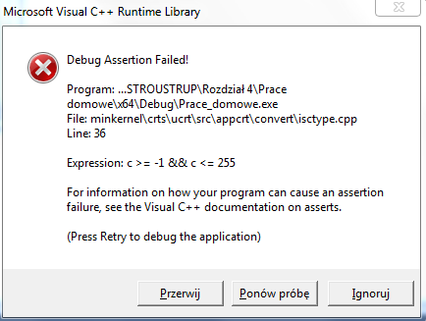

After selecting „Ponów próbę”

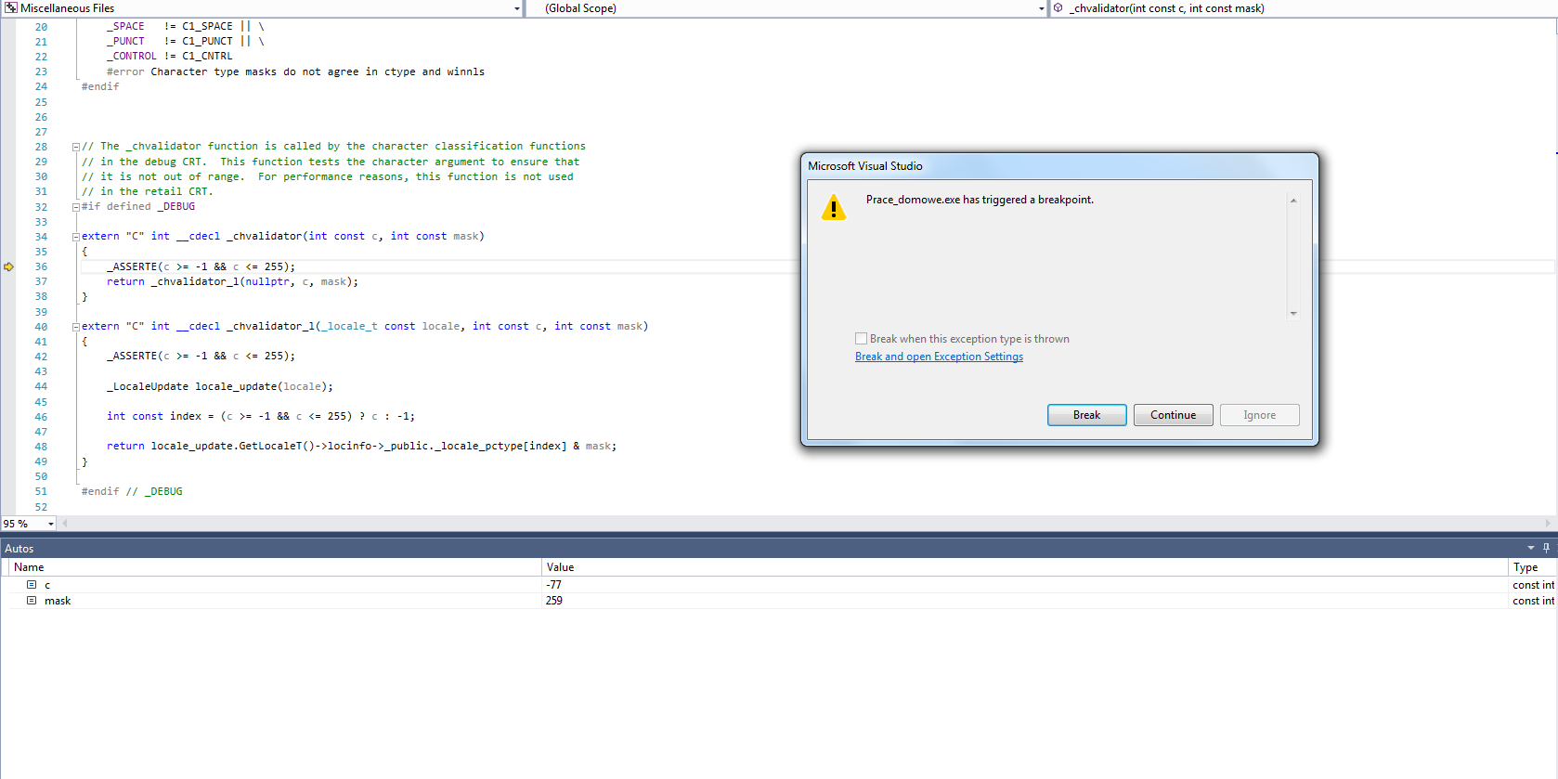

After selecting Continue

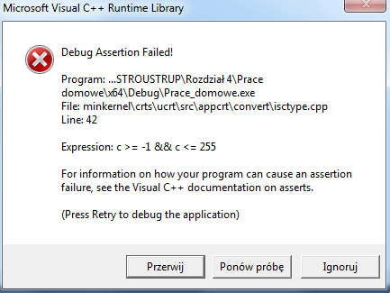

After selecting couple Times „Ponów próbę and “Continue”

